Lab 6.1 Commands & Args in YAML

1. Create a pod-definition.yml file as below:

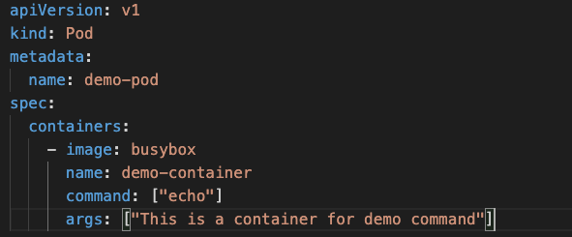

1. Create the Pod

**kubectl create -f pod-definition.yml**

1. Check the Logs in the Pod

**kubectl logs -f demo-pod**

1. Since this is a short running workload, kubernetes thinks that the app has crashed and will attempt to restart it. Keep observing the pod status and notice the Number of Restarts

**kubectl get pods**

1. To prevent the restarts, set the restart policy in pod-definition.yml

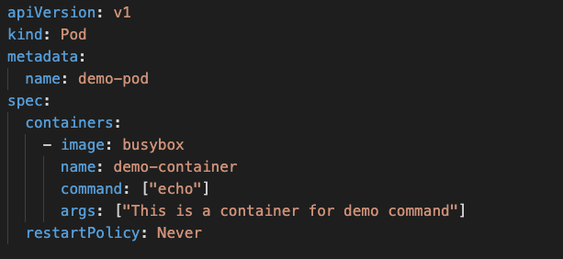

1. Delete the pod

**kubectl delete pod/demo-pod**

1. Recreate and notice the number of restarts

**kubectl create -f pod-definition.yml**